Uud 336,743
Prospects for the use of blockchain and cryptocurrencies technology in belarus
Semenchukova I.Y., Doc, Ph.D., Nemkina P.O., Student.
Vitebsk State University of Technology, Vitebsk, Belarus
The report. The article examines the essence and significance of blockchain and cryptocurrency technology, as well as the prospects for their use in the Republic of Belarus today.
Keywords: blockchain,distributed registry technology, smart contact, digital currency, cryptocurrency, crypto economy,mining, bitcoin, rate, prospects.
As the term "distributed registry technology" implies, blockchain technology is based on the ability to create and share unique digital records without a [5 centralized proxy.
A distributed database of this technology, consisting of blocks that include transactions (not necessarily financial), allows you to preserve all information about the transactions, as well as to protect the data from unauthorized change or hacking. This solution looks more reliable than the traditional implementation: the database is the central cserver responsible for security systemadministrator.
Because of its characteristics, blockchain offers the world unprecedented opportunities to distribute rewards for economic activity with much less risk of intercepting them and without the hidden costs associated with centralized, monopolistic or [5 crent-oriented . 114]. intermediaries.
Cryptocurrencies were the first mass testing of blockchain technology (distributed registry technology). The use of cryptocurrencies in monetary relations allows to cincrease the security and control ability of private money to beissued.
Cryptocurrency in the vast majority of cases is not provided with any goods and is not guaranteed by the state. Thus, its value is determined simultaneously on the basis of individual perception and how it is assessed by other members of society, i.e. the level of trust in it. Existing only in the form of code and having limited opportunities for direct exchange for goods (the function of the means of payment) cryptocurrency is nevertheless used as money. Its uniqueness in relation to fiat money is also that its limited turnover and regulation are actually ensured without the participation of the state.
Compared to the traditional monetary system, it is difficult to "reprint" digital money and thus cause inflation, to administratively limit/prohibit the use and conduct of transactions withcryptocurrencies.
To date, the scale of the use of cryptocurrencies does not give reason to believe that most subjects of the world economy are moving away from the use of fiat money in favor of cryptocurrencies. To date, there are about 1000 cryptocurrencies with a total market capitalization of 211.7 billion dollars. United States. Of these, $114.4 billion The U.S. or 54% is cbitcoin.
Onfo blockchain project in April 2020 conducted an experiment to see how quickly crypto assets in 4 different countries can gain popularity. Onfo founder J. R. Forsyth believes that the spread in developing countries has been faster, as small amounts of money in these regions are valued more, as well as factors such as the lack of a national credit system, кредитования, the growinggrowth ofsmartphones in the region and the effects of the COVID-19 pandemic.
So, COVID-19 has opened up new opportunities for the blockchain community inChina.
The Ministry of Human Resources and Social Welfare (MOHRSS) is forming job instructions for employees of these specialties and identifying the tasks they will have to perform. For example, Blockchain engineers design the Blockchain platform architecture, develop basic technical solutions for such systems, and deploy, test, operate, and maintain the system.
In turn, the Blockchain application operator tests the functions and stability of systems, develops processes and models for system applications, and is responsible for "monitoring, operating and maintaining system applications." It uses blockchain technology and tools to participate in the system in scenarios such as government affairs, finance, health care, education, etc.
Another nod to technology is the Chengdu University of Information Technology, which announced the launch of China's first bachelor's degree program in blockchain.
According to a survey by one of the largest Chinese recruitment companies, the entry-level specialists in the blockchain earn $2,300 per month. This is more than double the national average salary.
The popularity of cryptocurrency is considered to be the largest rate to the U.S. dollar. Among the many types you can distinguish the following currencies:
- Bitcoin (the first version of the cryptocurrency, appeared in 2009. ведущая, наиболее значимая и признанная криптовалюта);
- Ethereum (creation began in 2015.
- Litecoin (considered derived from bitcoin. It has less transaction time than bitcoin. The generation was launched in 2011.)
- Dash (formerly the currency was called Dark coin. 7).
- Ripple (often used for international real-time settlements, as well as currency exchange and remittances).
Everyone registered in the system can become the owner of the cryptocurrency. To do this, it is enough to create your own electronic wallet, verify your personal account and keep credentials in a safe place. The wallet is ready to be recharged as soon as the registration is7completed.
One way to buy cryptocurrency is mining.
Mining is the use of software and technology to ensure that the registry of transaction blocks (blockchain) operates by entering into a distributed registry (according to predetermined rules and principles) information about transactions committed between users.
Despite the technical limitations and difficulties associated with the mining and circulation of cryptocurrencies (low transaction processing speed, risk of system stability, etc.), individual states are already experimenting with digital money, as well as blockchain technology. However, the importance of the prospects for using c. 15]. cryptocurrencies for citizens, the state and business vary.
The origin of cryptocurrencies is primarily due to the advent of Bitcoin. Bitcoin, from bit - "bit" and coin - "coin") is a payment system that uses the ceponymous unit and the eponymous data transfer protocol.
Highlights of Bitcoin:
- All transaction information is available in the public registry from the first transaction,
- open source,
- is deflationary, the issue (issue) of coins is limited by the protocol,
- non-refundable transactions,
- transactions are anonymized, only the number of wallets of the system is used,
- electronic payment between the two parties takes place without intermediaries,
- there is an opportunity to attract a third-party guarantor with the help of - multi-signature,
- there is no way to block funds from outside,
- the possibilities of smart contracts (with some restrictions) are laid down,
- Bitcoins can be used to exchange for goods or services from sellers who agree to accept them,
- exchange for ordinary currencies takes place through an online digital currency exchange service, other payment systems or exchange offices.
The main drawbacks of Bitcoin:
- issuing money out of control,
- Illegal goods may be trafficked,
- speculative transactions with the formation of a financial pyramid.
The rate of bitcoin today is a real value because it is at this rate you can exchange your bitcoins for more understandable money - U.S. dollars.
Such a categorical statement has strong, objective evidence:
- All bitcoin purchase and sale transactions are made only at the current rate. Past courses, at least yesterday's, are history. The future is in the realm of assumptions.
- Bitcoin is the leading, most significant and recognized cryptocurrency. The US dollar is the most common and widely used of all currencies issued by states.
- The greatest impact on the BTC rate is the indicators of its supply and demand on virtual exchanges. And the bulk of bitcoin exchange transactions account for just its conversion into USD. Also at the current rate of 6 Bitcoin, purchases ofreal goods aremade.
The weighted average bitcoin rate today is $9,483.15and changes every day.
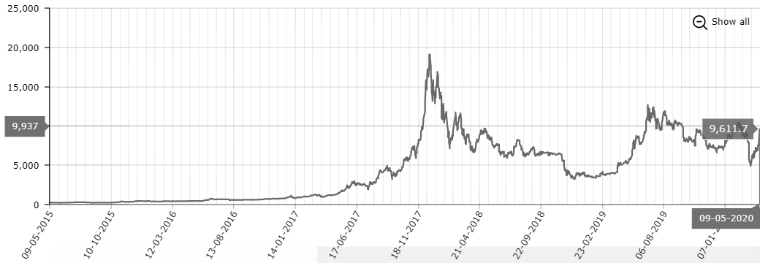
Figure 1 - Bitcoin exchange rate against the dollar for 2015-2020.
Источник: [6].
Also, the bitcoin exchange rate against other currencies can be considered in Table 1.
Table 1 - Rates of other cryptocurrencies (including bitcoin) for 15.05.2020 number, USD.
Currency | Cost | Capitalization | Volume (24h.) | Change (24 hours)
Bitcoin | 9483.15$ ^{-137.47} | 174 282 098 835$ | 805 333 000$ | -1.4289%
Ethereum | 198.59$ ^{+0.56} | 22 031 540 901$ | 86 037 800$ | +0.2828%
Ripple | 0.2001$ ^{-0.0012} | 20 008 369 343$ | 56 597 800$ | -0.5961%
Bitcoin Cash / BCC | 238.54$ ^{+0.74} | 4 391 037 377$ | 12 894 400$ | +0.3112%
Litecoin | 43.28$ ^{+0.05} | 2 814 038 355$ | 30 329 600$ | +0.1157%
Источник: [6].
The formation of the legal framework for the regulation of crypto-economy in the Republic of Belarus began with the signing of Decree No. 8 on the development of the digital economy (Figure 2) by the President of the Republic of Belarus on December 21, 2017.
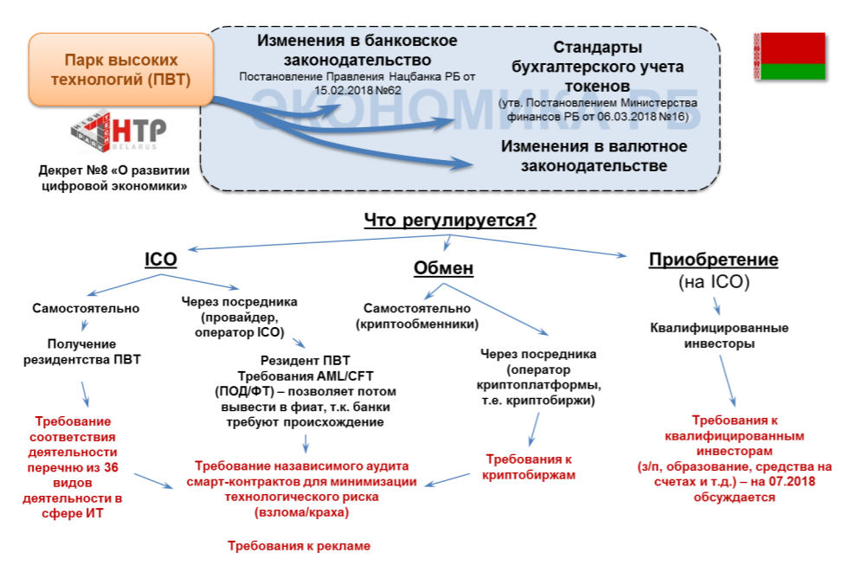
Figure 2 - Regulation of Crypto-Economics in the Republic of Belarus
Source:

In particular, the document defined such key concepts as "cryptocurrency," "mining," "blockchain," "smart contract," "crypto-platform operator" and others. In addition, the rights of legal entities and individuals to own cryptocurrencies were regulated and the main development institution in this area, the High Technology Park (PVT6), was defined.
Thus, the first steps have been taken to form an institutional environment and regulatory field for cryptocurrency and blockchain activities.
According to the Decree, the main institution responsible for developing regulatory principles in the cfield of cryptocurrency transactions is the High Technology Park.
Other state bodies of the Republic of Belarus are also moving quickly enough in adopting the necessary regulations for the development of crypto economy. Thus, in February 2018, the National Bank of belarus amended the regulation on the rulesof internal control carriedout by banks, which allowed banks to open accounts to crypto-economy entities, including miners.
In 2018, the development of the Decree in the Republic of Belarus was amended to the banking legislation, which establish the procedure of banks with tokens (including cryptocurrencies), operators working with these assets. The Ministry of Finance of the Republic of Belarus, with the participation of experts, created a standard for the financial accounting of crypto assets. Thus, participants of economic relations reflect these assets in accounting (created and placed token - obligation; acquired in any way, including mining - an asset). It is worth noting that this standard cis the best international experience.
In regulating the activities of the crypto-platform operator (crypto-exchange) in the Republic of Belarus, the requirements for the activities of forex companies were taken as the basis.
One of the most important rules implemented in the legislation of the Republic of Belarus is the five-year tax break. The taxation principles apply to transactions with cryptocurrencies until 2023, after 2023 the same tax principles apply to the same as for the asset, the rights to which the token certifies. In addition, there are exemptions from currency controls. [3, c.35].
In 2015, a company of enthusiasts created the first blockchain company in Belarus. The Cryptosode project was created with the aim of building the first major bitcoin mining center. Cryptosode quickly became the leader of mining in the region: today the company owns mining farms in Belarus and China.
By the 2030s, different versions of distributed registry technologies - or blockchain - could significantly change everything from online financial transactions to ways to vote and address product manufacturing issues. Widespread use of blockchain technologies may be a turning point in history, but so far 5these technologies themselves and the possibilities for their application are at an early stage of development.
The Republic of Belarus has made great strides in the legal implementation of everything related to the digital economy and in particular blockchain.
Although blockchain is moving in the material world in modest steps, it is making great strides in its "native" digital environment. By becoming the basis for bitcoin and other cryptocurrencies, blockchain has attracted billions of dollars in currency and other assets, although not without some cost adjustments. Blockchain has great potential for application in the financial industry and many prospects for benefit, including the possibility [5of expanding the availability of financial services and markets by providing access to them without the need to contact the cbank.
List of sources used:
- Babkin, A.V., Burkaltseva, D.D., Pshenichnikov, V.V., Tyulin, A.S. Cryptocurrency and Blockchain Technology in the Digital Economy: the Genesis of Development / Scientific and Technical statements of St. Petersburg State Polytechnic University. Economic sciences. 2017. No5. –2017. S. 9-22.
- Kononev, N., Mazurov, S. Prospects for the application of blockchain technology in the Republic of Belarus / Bank Gazette. – 2017. S. 66-71.
- Cryptocurrencies and blockchain as attributes of the new economy. Development of regulatory approaches: international experience, practice of EAEU member states, prospects for application in the Eurasian Economic Union. - M.: EEC 2019. 74 s.
- MTBlog. Access mode: https://mtblog.mtbank.by/.- Access date 24 February 2020.
- Schwab, K., Davis, N. Technology Fourth Industrial Revolution / Schwab, K., Davis, N.M.: Exmo, 2018. S. 333.
- Myfin.by "Electronic Resource". - Access mode: https://myfin.by/. The access date is February 24, 2020.
- Alpari "Electronic Resource" - Access mode: https://alpari.com/. - Access date 24 February 2020.
- Profit Gid [Electronic resource]. – Access mode: https://profitgid.ru/. – Access date 02.06.2020.

