UDK 338.24 / BBK У054.3
Svetlana Tuinova*
Jim Kinnibrugh**

ARCTIC COMFORT UNDER COVID-19 AND DIGITALISATION

*Tuinova Svetlana Sergeevna (Russia, Apatity) - PhD, researcher, the Luzin Institute for Economic Studies - Subdivision of the Federal Research Centre "Kola Science Centre of the Russian Academy of Sciences" (IES KSC RAS), e-mail: touinova@iep.kolasc.net.ru
**Kinnibrough Jim (Great Britain, Stoke-On-Trent) - Director of Kamintech, Chartered Institution of Building Services Engineers (CIBSE) council member, e-mail: jim.kinni@zen.co.uk

Abstract: This research addresses the questions, “what is Arctic comfort” and “how has COVID-19 and global digitalisation impacted the dwelling sector of the Northern region economy”. The article begins with an historical review of how the Artic has previously been occupied and populated. This work then considers the environmental consequences that were observed during the period of Arctic industrialisation and concludes by proposing a basic design of what a successful contemporary Arctic dwelling could look like taking into account green energy. It identifies 60+ enablers that could help define and shape “Arctic comfort”. Gained answers and gathered information lead us to prognose three scenarios in the dwelling sector of economy in the Arctic region.

Key words: Arctic comfort, Sustainable dwellings, Green Energy, Digitalisation, COVID-19

Introduction:
The relevance of this article is determined by how the COVID-19 pandemic has generated a worldwide reappraisal of city living, with growing numbers of people escaping urban confines in search of green space and fresh air. City dwellers are moving en-masse to rural areas as the pandemic exposes the inadequacies of working remotely from home in accommodation that has limited private space. [1] There is a big difference between being “locked down” in a city block building apartment and being “locked down” in a country cottage. Worldwide lock down has created a new digital society and has substantially changed the ways people interact - distance education, consumer behaviour and remote working. [2,3]
The focus of this study is to predict how this migration of people will influence the regional economy of the Arctic and, in particular, the Murmansk region. This work seeks to establish what is “Artic comfort” with regard to designing and constructing affordable, sustainable Arctic dwellings. It identifies the following tasks: to carry out an historical review of how Arctic dwellings have developed over time; to define Arctic comfort and highlight threats to achieving Arctic comfort; to elaborate proposals to manage the challenges that lie ahead to achieve Artic comfort.
This investigation has been conducted using a systematic method of research based upon the deep analysis of a wide range of data. The subject of this investigation is hugely complex with inter relating and interacting elements. Additionally, the changing face of the economy in the Artic system introduces social challenges that never existed before. These are addressed in this investigation as far as green energy and new technology achievements.
This work is a collaborative exercise providing both a scientific perspective and an engineering perspective within the framework of the research project: 0226-2018-0004_IEP "Interaction of global, national and regional factors in the economic development of the North and the Russian Arctic" on point PFNI 167 "Research of the dynamics of the ratio of global and national in socio-economic development and optimization of Russia's participation in the processes of regional and global integration". The research methodology that has been adopted is based upon extensive perusal of a wide range of internationally published articles [4,5,6,7,8,9,10] and findings of interviews conducted across a broad range of diverse demographic populations.

Results and Discussion:
Historical review identifies three major phases of Arctic occupation and population:
I. Indigenous occupation: Reindeer herding, hunting, fishing, foraging berries and wild plants, dwellings made of natural materials and animal skins. For example, igloos were used as a temporary shelter on extended winter trips, not as a permanent home. This required advanced skill levels in animal domestication and a close relationship with the environment. Turf huts or earth huts, were a common form of dwelling. They were robust and insulated enough to live in for longer periods of time. Tent houses, or tipi-like constructions, were built partly under the earth or fully above the earth. It is noted by Jack Herbet (Founder and CEO of the Cold Climate Housing Research Centre in Canada) that “Before the white man came, we lived in the ground and we buried our dead in the air, atop the Tundra. After the white man came, we buried our dead in the ground, we lived in the air and we have been cold ever since!” [10]
II. Early Exploration (1500s to 1800s). Arrival of explorers, geologists, scientists. These were “seasonal” visitors living in “temporary” accommodation. Europeans started venturing north into Arctic regions of Scandinavia and Russia as early as a thousand years ago [11]. Much exploration took place in the 18th and 19th centuries. There was a dependency on having good inter-relationships with both the indigenous populations and with the local environment. The hut has been the most common polar shelter used by explorers. Huts built during the heroic age were primarily made of wood [12]. They would be designed to keep heat in while providing as much living space as possible using extremely limited amounts of material. These huts would be simple in design, usually consisting of one main room or perhaps a main living area and a smaller room for scientific experimentation. There were four goals to major polar exploration at this time. The discovery and navigation of a “Northwest passage” (connecting the Atlantic and Pacific oceans); reaching the North Pole; traversing Greenland and discovering the fate of the lost John Franklin expedition of 1845. From 1818 to 1909, 35 government funded and 57 privately funded expeditions sought to locate and navigate a Northwest Passage, discover the North Pole and make other significant discoveries in the Arctic region. [13]
III. Large Scale Industrialisation of the Arctic began when governments implemented funded programs to explore and extract natural resources. It was characterised by the construction of large concrete buildings and the use of large amounts of metal. There were a number of leaders of the country during this time. The architecture of the Stalin leadership (to 1953) was characterised by grand and palatial civic buildings which are still functional and in good standing. Residents of these buildings are privileged. The architecture of Khrushchev (to 1964) and Brezhnev (to 1982) was characterised by high volume, quick build, small apartments to give each family a separate dwelling. Today, these buildings are starting to decay, some buildings are already empty because they are not safe to live in. Residents of these buildings are more vulnerable to COVID-19.
To summarise, the historical review of occupation in the Arctic shows that today the Indigenous populations continue their nomadic practices and retain the ability to create seasonal dwellings. These peoples also own permanent dwellings (with electricity, sewerage and central heating) bestowed to them during the Soviet era as part of the Soviet policy that every family has a right to have their own dwelling. The indigenous populations account for 10% of the people living in the Arctic. Following the demise of the Soviet period, Arctic city populations are increasingly vulnerable to new social pressures bought about by capitalism. Poor or old peoples without family connections have few options other than to remain where they are until they die. Unskilled workers, also have few options to better themselves. Skilled, professional or wealthy peoples have options to remain in their city but also have access to country dwellings within the Arctic and outside of the Arctic. These demographics, shape how COVID-19 and global digitalisation impact sectors of society differently.
Arctic comfort is defined as a secure dwelling where every family member can be safe from extreme weather and be motivated to learn and adapt to remote working. To define Arctic comfort more exactly, we need to consider both the threats and difficulties, that historically, have been observed from living in Arctic dwellings and the steps that must be taken to mitigate these observed threats to generate our proposal.
In consideration of current threats (see Figure 1) to living in the Arctic, it can be observed the passing of time and of climate change shows us that building sustainable dwellings in the Arctic is challenging. Melting permafrost damages dwelling foundations incurring high renovation and maintenance costs. There is a very high reliance on the transporting of building materials during a small seasonal window. [14] Maintenance of dwellings and warranty of materials is disproportionately high. Antiquated & unreliable equipment leads to failures and to an increasing dependency on diesel and exorbitant heating costs. Transport and (unskilled/skilled) worker labour costs are prohibitively high. Unmaintained buildings with rotting materials result in poor, damp, mouldy conditions. Inadequate air circulation leads to heightened susceptibility to respiratory illnesses and lower than average life expectancy.
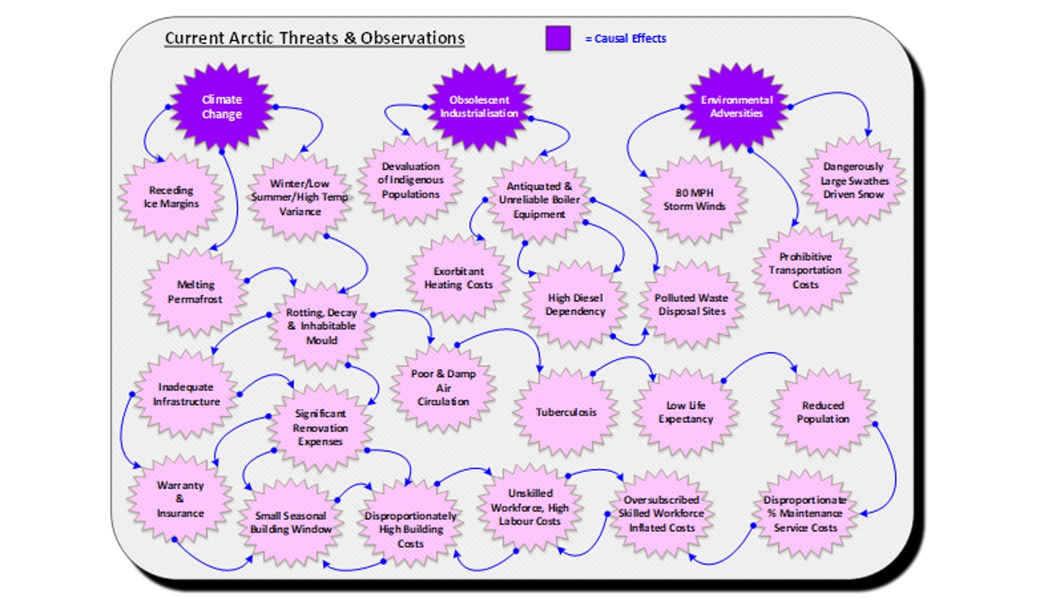
Figure 1. Historical observations of challenges to live in the Arctic
Studies with indigenous populations identify key features (see Figure 2) that can bring about Arctic comfort: a strong connection to light, clear open flowing lines that lead to efficient insulation, shared communal areas with good air circulation, passive heat warming and maximisation of natural sunlight. Shared communal areas are valued because many people can come together and sit together during brutal storms. Of upmost importance to an indigenous dweller is anecdotally, the availability of a “porch” (an unheated enclosed area sitting between the colder outside temperatures and the warmer inside temperatures). A porch allows captured or other perishable food stuffs to be safe from scavenging animals. A porch allows a free space to maintain essential equipment such as sleds/skis. [15,16]
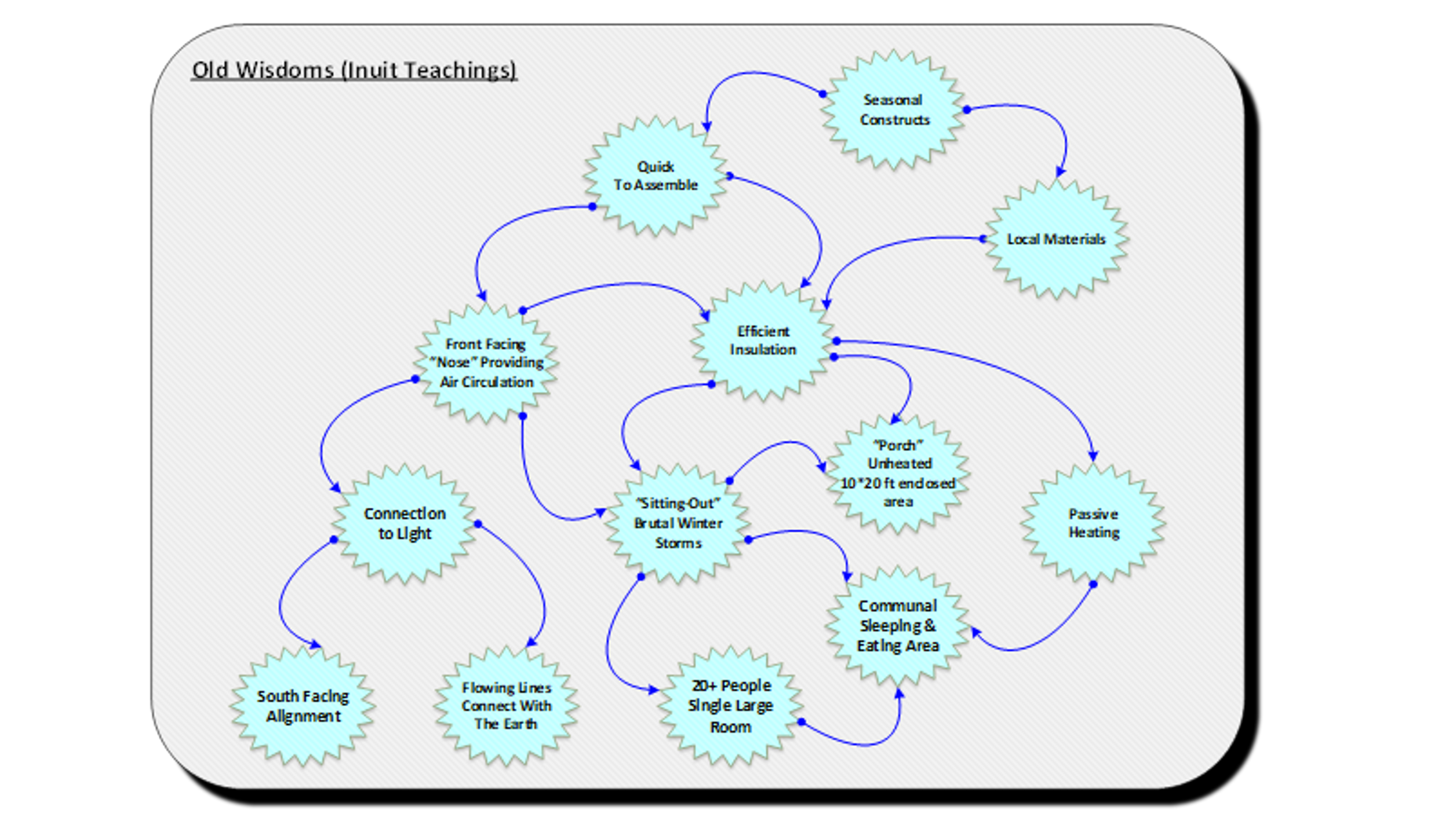
Figure 2. Old Wisdoms from Indigenous populations
From the above, we can elaborate proposals (see Figure 3) to better achieve Artic comfort by designing:
* A streamlined dwelling form to lessen impacts of storm driven winds and storm driven snow.
* Insulated walls / floors using lightweight thermal mass materials that are transportable and can be rapidly built by unskilled workforces operating in harsh conditions.
* Expandable (joints) to enable the dwelling to survive changing permafrost/ground floor temperatures
* Extendible stilts to heighten the dwelling during periods of and ground flooding from seasonal melting ice boundaries
* A purposeful and fully engaged space that is purposeful in its entirety and its usage. This will include a front facing, open plan communal area with air pump technology to circulate healthy, clean air through the living space for every hour of the day
* A spine of heat generating facilities (washing machines, baths, saunas cooking areas) supporting, loft style, bed spaces and an optional rear multipurpose ground floor room (to use as a bedroom or a study or a meditative private space)
* A south facing clerestory to reflect and disperse natural light plus maximise the potential of solar power capability
* Side wall storage areas to separate outside colder wall structures from warmer inside living areas
* Design a porch, an unheated area for food preservation and essential equipment maintenance
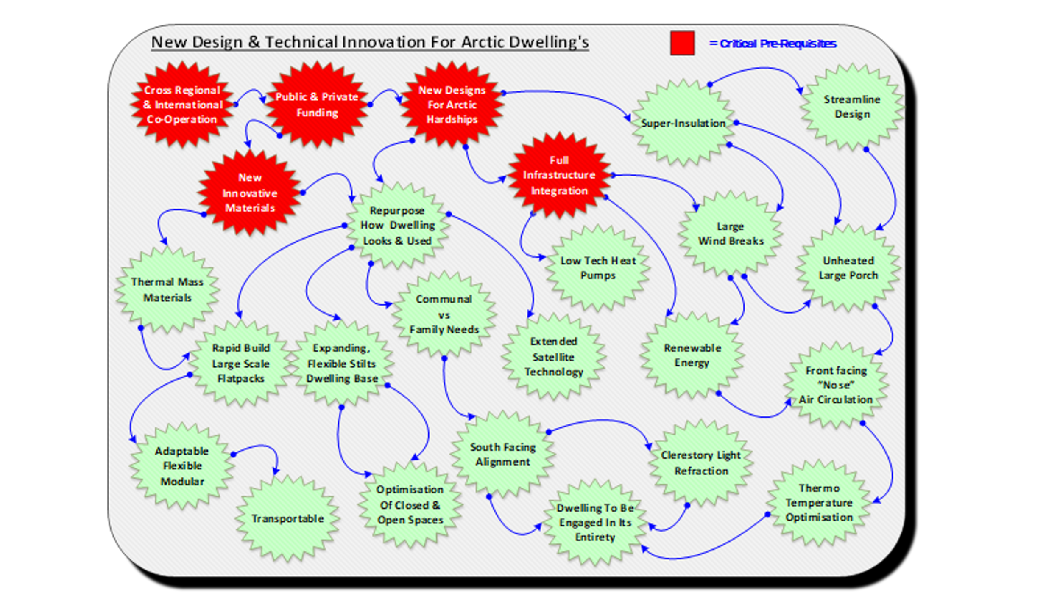
Figure 3. New Design and Technical Innovation for Arctic Dwellings

Critical Prerequisites to enable new design and technical innovation for Artic hardships include: Cross Regional and International Co-Operation; Public and Private Finding; Full Infrastructure Integration; Full Satellite and communications capability; Renewable energy capability; Balanced air circulatory capability; How dwellings look and are used.

Conclusion:
One can conclude that “Arctic comfort” is a complex balance of many inter-relating parts that cannot easily be achieved during COVID-19. Modern digital social practices may provide some possibilities for increasing levels of “Artic comfort”. Technical innovations and new conceptual designs (detailed in our proposal above) can provide opportunities to increase “Arctic comfort”. This investigation identified 60+ enablers that help to shape and define “Artic comfort” (see Fig. 4).
One can prognose differing scenarios for upper, middle and lower classes groupings according to their respective levels of education, work skill, wealth and health. COVID-19 effects these groupings differently because their access to digital technology is unequal. Lower class people are old single people or are single people with poor health (disabilities) and low income (for example, a pension). They have few prospects. They and their dwellings will disappear first. Middle-class people range from young uneducated people, unskilled workers to skilled labour. These people do have family connections and do have reliable income streams. They survive and may strive to become upper-class, but in unfortunate circumstances they can slip into becoming lower-class. COVID-19 and digitalisation are examples of such circumstances. Upper-class people already own additional separate dwellings such as high spec apartments, country cottages, dwellings in Southern part of Russia and sometimes abroad. They always have the ability to further increase their dwelling comfort.
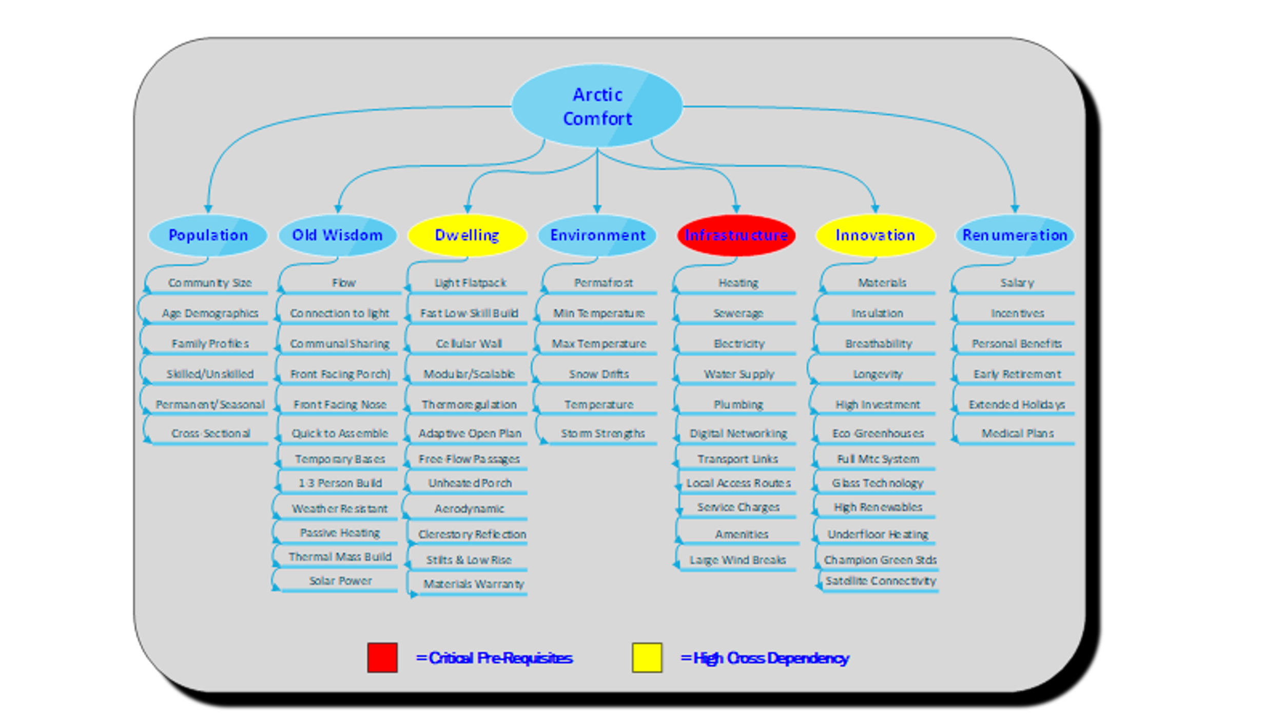
Figure 4. 60+ enablers that help to shape and define “Artic comfort”

References:
- Jesse Matheson, Max Nathan, Harry Pickard and Enrico Vanino. Why has coronavirus affected cities more than rural areas? – 2020. - [Electronic Resource] - URL: https://www.economicsobservatory.com/why-has-coronavirus-affected-cities-more-rural-areas (date of access: 03.03.2021)
- Litvinova A. Who will lead digitalization in the Arctic? – 2020. -.[Electronic Resource] - URL: https://forpost-sz.ru/en/a/2020-12-07/who-will-lead-digitalization-arctic (date of access: 03.03.2021)
- Virtual Conference | COVID-19 Impacts in the Arctic. – 2020. - -.[Electronic Resource] - URL: https://www.wilsoncenter.org/event/virtual-conference-covid-19-impacts-arctic (date of access: 03.03.2021)
- European Think Tanks Group. COVID-19 in the Arctic. How the EU’s new Arctic policy should take account of the pandemic. - 2020. - [Electronic Resource] - URL: https://ettg.eu/2020/12/23/covid-19-in-the-arctic-how-the-eus-new-arctic-policy-should-take-account-of-the-pandemic/ (date of access: 03.03.2021)
- Cold Climate - Housing research Centre. Thermal Mass Study. [Electronic Resource] - URL: http://cchrc.org/thermal-mass-study/ (date of access: 03.03.2021)
- Vlasova T., Petrov A. N., Volkov S. Rethinking Sustainability monitoring in the Arctic [text]. MDPI or Multidisciplinary Digital Publishing Institute. [Electronic Resource] - URL: https://www.mdpi.com/journal/sustainability (date of access: 03.03.2021)
- Gassiy V., Stoikov V. Renewable energy and green construction in the Arctic – 2020. - [Electronic Resource] - URL: https://www.e3s-conferences.org/articles/e3sconf/pdf/2020/67/e3sconf_fpepm2020_02008.pdf (date of access: 03.03.2021)
- Ronald O'Rourke, Laura B. Comay & others. Changes in the Arctic: Background and Issues for Congress – 2021. - [Electronic Resource] - URL: https://crsreports.congress.gov/product/details?prodcode=R41153 (date of access: 03.03.2021)
- Centre for Maximum Potential Building Systems. The sustainable building Sourcebook [Electronic Resource] - URL: https://p2infohouse.org/ref/20/19122/contents.html (date of access: 03.03.2021)
- Gregory Scruggs, Thomson Reuters Foundation. Homes like parkas? Shivering Arctic dwellers may need housing rethink – 2019. - [Electronic Resource] - URL: https://www.reuters.com/article/housing-arctic-energy-idINL5N22A0CV (date of access: 03.03.2021)
- NSIDC National Snow and Ice Data Centre. All About Arctic Climatology and Meteorology, Arctic People. – 2020. - [Electronic Resource] - URL: https://nsidc.org/cryosphere/arctic-meteorology/arctic-people.html#:~:text=Europeans%20started%20venturing%20north%20into,most%20of%20the%20Northern%20Hemisphere. (date of access: 03.03.2021)
- Freeze Frame — Scott Polar Research Institute. Shelter in the Polar Regions. [Electronic Resource] - URL: https://www.freezeframe.ac.uk/resources/shelter (date of access: 03.03.2021)
- Daniel K. Benjamin. Arctic Expeditions of the 19th Century – 2001. - [Electronic Resource] - URL: https://www.perc.org/2001/06/01/arctic-expeditions-of-the-19th-century/ (date of access: 03.03.2021)
- Turkel J. A. Arctic House – 1999. - [Electronic Resource] - URL: https://dspace.mit.edu/bitstream/handle/1721.1/70314/42724170-MIT.pdf?sequence=2 (date of access: 03.03.2021)
- Stewart E. J., Draper D. & Johnston M. E. A Review of Tourism Research in the Polar Regions – 2005. -[Electronic Resource] - URL: https://www.jstor.org/stable/40513105?seq=1 (date of access 03.03.2021)
- Mackin N.P. Future architecture, ancient wisdom: adaptable structures from arctic tradition – 2017. - [Electronic Resource] - URL: https://www.witpress.com/Secure/ejournals/papers/CMEM050417f.pdf (date of access: 03.03.2021)

