УДК 378
Русакевич П.
Садоха В.Е.

РЕЙТИНГ САЙТОВ ОБРАЗОВАТЕЛЬНЫХ ОРГАНИЗАЦИЙ БЕЛАРУСИ, ПРЕДЛАГАЮЩИХ ОБУЧЕНИЕ НА АНГЛИЙСКОМ ЯЗЫКЕ

Аннотация: рассматриваемый вопрос касается сайтов белорусских вузов, осуществляющих обучение на английском языке, анализа ключевых особенностей веб-страниц в зависимости от региона.
Основная проблема заключается в том, что в условиях стремительно развивающейся пандемии, появились сложности в выборе университета в удаленных условиях, в частности для иностранных англоязычных студентов. Было принято решение изучить веб-сайты учебных учреждений, предоставляющих обучение на английском языке, чтобы определить примерный уровень дистанционной привлекательности университетов для иностранных студентов, определить уровни каждого региона в пределах выбранного рейтинга и проанализировать причины образования интервалов в уровне среди регионов Беларуси.
Исследование показало, что Витебская и Минская области оказались оснащены самыми эффективными веб-страницами с точки зрения выбранного рейтинга, что связано преимущественно с осложненными условиями конкуренции в данных регионах.
Практическая значимость заключается в том, что в связи с ситуацией в мире данное исследование может помочь белорусским университетам проанализировать уровень интереса учреждения для иностранных студентов, чем самым привлечь большее количество англоязычных абитуриентов в страну.
Ключевые слова: высшее образование, университет, вебсайт, рейтинг, образование на английском языке.

The purpose of this paper is to determine the degree of development of the English-language segment of Belarusian education by regions, to identify problem areas and to identify assumptions about the state of attractiveness of Belarusian English-language education through the prism of the official websites of institutions.
The traditions of Belarusian education, combined with constant development, as well as the use of modern approaches and attractive prices for education, contribute to the popularization of Belarusian education among foreign citizens.
As the results of surveys regularly conducted among foreign students and graduates of Belarusian educational institutions show, foreigners are also attracted by the high level of safety in the country, friendliness of Belarusians, the opportunity to work in their specialty during their studies.
In the academic year 2021/2022 about 27,000 foreign citizens from 109 countries of the world are studying in educational institutions of the Republic of Belarus. 25,12 thousand of them are studying in higher education institutions [1].
The largest number of students come to Belarus from Turkmenistan, China, Uzbekistan, Russia, Sri Lanka, Tajikistan, Lebanon, India, Iran, Kazakhstan and Azerbaijan [2].
This paper analyzed all of the websites of educational institutions in the country that provide education in English in order to examine whether there are any correlations between the degree of development of the institutions' websites with any of the statistics, such as GDP, number of institutions of higher education, and regional competitiveness rankings, using regional data as a basis.
The state educational institutions that provide their educational services in English were selected for evaluation. They were evaluated on the basis of C and U indicators, which will be described below. Only the English-language versions of the websites were used for comparison in order to assess the degree of relevance of the information specifically for foreign applicants.
The websites of 30 public institutions with the ability to teach disciplines entirely in English were selected for evaluation. To calculate the rating, an index was used, which is calculated on the basis of the values of 2 micro indices: Content (C) and Usability (U) [3, с. 78].
The first micro index characterizes the quality of the content, the second - the usability of the site, which helps to take into account all the nuances of using the site. The C and U micro indices are considered to be of equal value, i.e. the weight of each of them in the final index is 50%. Thus, it is calculated by the formula: I = 0,5 * (C + U) [3, с. 78].
Micro indices are calculated based on the values of the indicators presented in Table 1 (Value of the indicators).

Table 1.
Value of the indicators. [3, с. 78]
Content |  | Usability
Indicators | % | Indicators | %
General information about the university (C1) | 20 | The logic of structuring information (U1) | 35
Contacts (С2) | 30 | Website search function (U2) | 25
Information about faculties (С3) | 30 | Map of site (U3) | 25
University News (C4) | 20 | Correct operation of links and other elements of the site (U4) | 15

Each of the indicators is evaluated on a two-point scale and takes a value of 0 or 1. Indicators C1-C4, (U2, U3) are scored "1" if the corresponding information block or tool (search tool, map) is present on the site, otherwise it is scored "0". The U1 index is "1" if the content of the sections of the site corresponds to the names of the sections, the names of the sections are perceived unambiguously, there is no duplication of information; otherwise it is "0". If checking the correctness of the links on the home page, as well as top-level menu items were detected 1 or more errors, then the index U4 is exposed "0", otherwise - "1" [3, с. 78].
Thus, after calculating the results, the two institutions with the strongest competitive websites for each region were identified, which are shown in Table 2 (An analysis of the websites of the region's top universities).

Table 2.
An analysis of the websites of the region's top universities [Author’s calculations].
Region | University | C1 | C2 | C3 | C4 | С | U1 | U2 | U3 | U4 | U | I
Моgilev | Mogilev S Kuleshov U | 1 | 1 | 1 | 1 | 1 | 1 | 1 | 1 | 1 | 1 | 1
Моgilev | BSAA | 1 | 1 | 1 | 1 | 1 | 0 | 1 | 1 | 0 | 0,5 | 0,75
Brest | Brest STU | 1 | 1 | 1 | 1 | 1 | 1 | 1 | 1 | 1 | 1 | 1
Brest | PSU | 1 | 1 | 1 | 1 | 1 | 1 | 1 | 1 | 0 | 0,85 | 0,925
Gomel | BSUT | 1 | 1 | 1 | 1 | 1 | 1 | 1 | 1 | 1 | 1 | 1
Gomel | Francisk Skorina Gomel SU | 1 | 1 | 1 | 1 | 1 | 0 | 1 | 1 | 1 | 0,65 | 0,825
Minsk | BSU | 1 | 1 | 1 | 1 | 1 | 1 | 1 | 1 | 1 | 1 | 1
Minsk | BNTU | 1 | 1 | 1 | 1 | 1 | 0 | 1 | 0 | 0 | 1 | 1
Vitebsk | VSMU | 1 | 1 | 1 | 1 | 1 | 1 | 1 | 1 | 1 | 1 | 1
Vitebsk | VSU of Masherov | 1 | 1 | 1 | 1 | 1 | 1 | 1 | 1 | 1 | 1 | 1
Grodno | GSAU | 1 | 1 | 1 | 1 | 1 | 0 | 1 | 1 | 1 | 0,65 | 0,825
Grodno | GSMU | 1 | 1 | 1 | 1 | 1 | 0 | 0 | 1 | 1 | 0,4 | 0,7

Then, an analysis of each of the regions was carried out, after which the percentage of areas according to the rating of websites was revealed, illustrated in Table 3.

Table 3.
Percentage of ratings by region [Author’s calculations].
Region | Average for the region | Average for the region in %
Mogilev | 0,875 | 15,87%
Brest | 0,9625 | 17,46%
Gomel | 0,9125 | 16,55%
Minsk | 1 | 18,14%
Vitebsk | 1 | 18,14%
Grodno | 0,7625 | 13,83%
Total | 5,5125 | 100,00%

When comparing the percentage of GDP by region and the ranking of websites by region, no explicit correlations were found (Figures 1, 2, 3, 4). It is worth bearing in mind that in the calculations the Minsk region was counted as Minsk, due to the absence of universities in the Minsk region outside of Minsk. However, when comparing the percentage number of educational institutions across the six regions, a certain correlation was found: almost all regions were developed in proportion to the degree of website development.

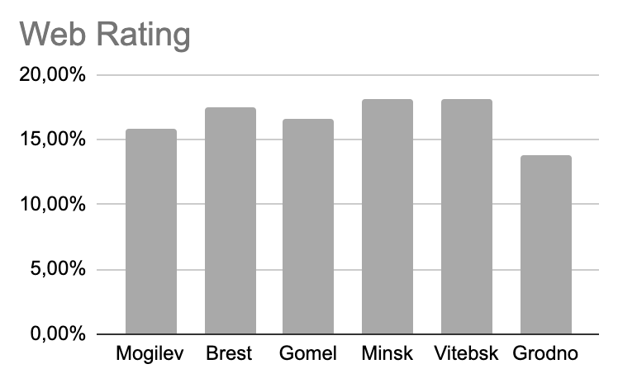
Figure 1. Web site rating of universities in the regions of Belarus [Author’s calculations].

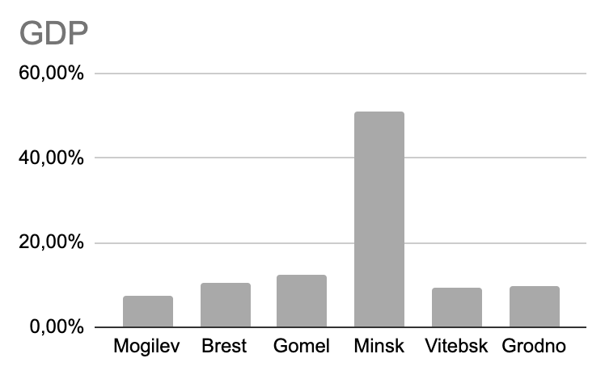
Figure 2. GDP of the regions of Belarus [Author’s calculations].

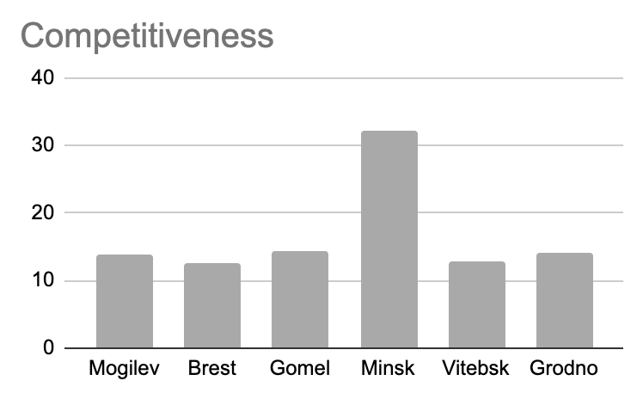
Figure 3. Competitiveness of the regions of Belarus [Author’s calculations].

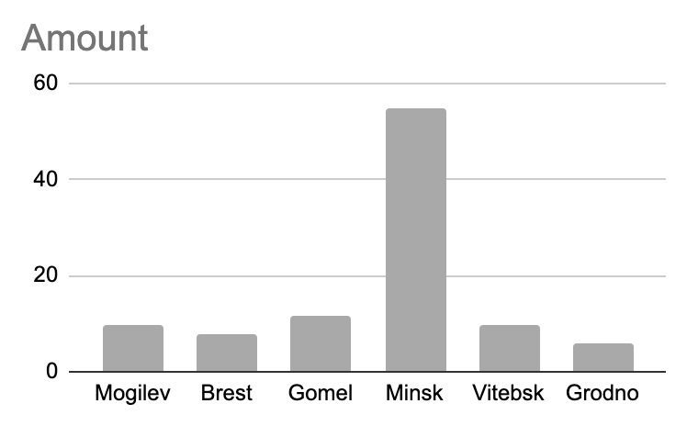
Figure 4. Amount of universities in the regions of Belarus [Author’s calculations].

An independent study among foreign students in Belarus was conducted, which showed that more than 70% of foreign applicants use university websites when choosing a place to study [Author’s study]. Therefore, it can be assumed that due to the high competition between a large number of educational institutions per region a greater number of university resources are allocated specifically for the development of web pages. Therefore, in regions where the number of competitive institutions is much smaller, there is no great need to update the web pages.
In conclusion, after analyzing the websites of Belarusian universities, we can conclude that English-language programs are developed everywhere in all regions of Belarus. This is more pronounced in the regions with the largest number of universities in the region, due to the increased competitiveness and high conversion rate of websites when applicants search for a place of study. It was found that the degree of development of websites in the regions is in no way correlated with the data of GDP by region, nor with the competitiveness of the regions of the country.

Библиографический список
1. В Беларуси обучается около 27 тыс. иностранных студентов. // [Электронный ресурс]. Режим доступа: https://www.belta.by/society/view/v-belarusi-obuchaetsja-okolo-27-tys-inostrannyh-studentov-466181-2021/ – Дата доступа: 20.03.2022.
2. Учиться в Беларуси. // [Электронный ресурс]. Режим доступа: https://president.gov.by/ru/belarus/social/education/foreigners – Дата доступа: 20.03.2022.
3. Экономическая информатика. Лабораторный практикум / Е. А. Манюкович [и др.] – Минск: БГУ 2015. – Дата доступа: 20.03.2022.

Информация об авторах
Русакевич Полина Дмитриевна (Беларусь, Минск) – студентка 3 курса специальности Бизнес-администрирование, Институт Бизнеса БГУ (ул. Обойная 7, sbmt@bsu.by).

Rusakevich P. D.

Садоха Валерия Евгеньевна (Беларусь, Минск) – студентка 3 курса специальности Бизнес-администрирование, Институт Бизнеса БГУ (ул. Обойная 7, sbmt@bsu.by).

Sadokha V. E.

Железко Борис Александрович (Беларусь, Минск) – кандидат технических наук, доцент, Институт Бизнеса БГУ (ул. Обойная 7, sbmt@bsu.by).

Zhelezko B.A.

RATING OF WEBSITES OF EDUCATIONAL ORGANIZATIONS IN BELARUS OFFERING STUDIES IN ENGLISH

Annotation: the issue under consideration concerns the websites of Belarusian universities providing education in English, the analysis of the key features of web pages depending on the region.
The main problem is that in the context of a rapidly developing pandemic, it has become difficult to choose a university in remote conditions, in particular for foreign English-speaking students. It was decided to study the websites of educational institutions providing education in English in order to determine the approximate level of distance attractiveness of universities for foreign students, to determine the levels of each region within the selected ranking and to analyze the reasons for the formation of intervals in the level among the regions of Belarus.
The study showed that the Vitebsk and Minsk regions were equipped with the most effective web pages in terms of the selected rating, which is mainly due to the complicated conditions of competition in these regions.
The practical significance lies in the fact that in connection with the situation in the world, this study can help Belarusian universities analyze the level of interest of the institution for foreign students, rather than attract more English-speaking applicants to the country.
Key words: higher education, university, website, rating, education in English.

Author information
Rusakevich Polina Dmitrievna (Belarus, Minsk) – 3rd year student of the major Business Administration, School of Business of Belarusian State University (7, Oboinaya St., sbmt@bsu.by).

Sadokha Valeria Evgenievna (Belarus, Minsk) – 3rd year student of the major Business Administration, School of Business of Belarusian State University (7 Oboinaya St., sbmt@bsu.by).

Zhelezko Boris Alexandrovich (Belarus, Minsk) - candidate of technical ciences, Associate Professor, School of Business of Belarusian State University (7, Oboinaya St., sbmt@bsu.by).

Bibliographic list
1. В Беларуси обучается около 27 тыс. иностранных студентов. // [Electronic source]. Mode of access: https://www.belta.by/society/view/v-belarusi-obuchaetsja-okolo-27-tys-inostrannyh-studentov-466181-2021/ – Date of access: 20.03.2022.
2. Учиться в Беларуси. // [Electronic source]. Mode of access: https://president.gov.by/ru/belarus/social/education/foreigners – Date of access: 20.03.2022.
3. Экономическая информатика. Лабораторный практикум / Е. А. Манюкович [и др.] – Минск: БГУ 2015. – Date of access: 20.03.2022.

